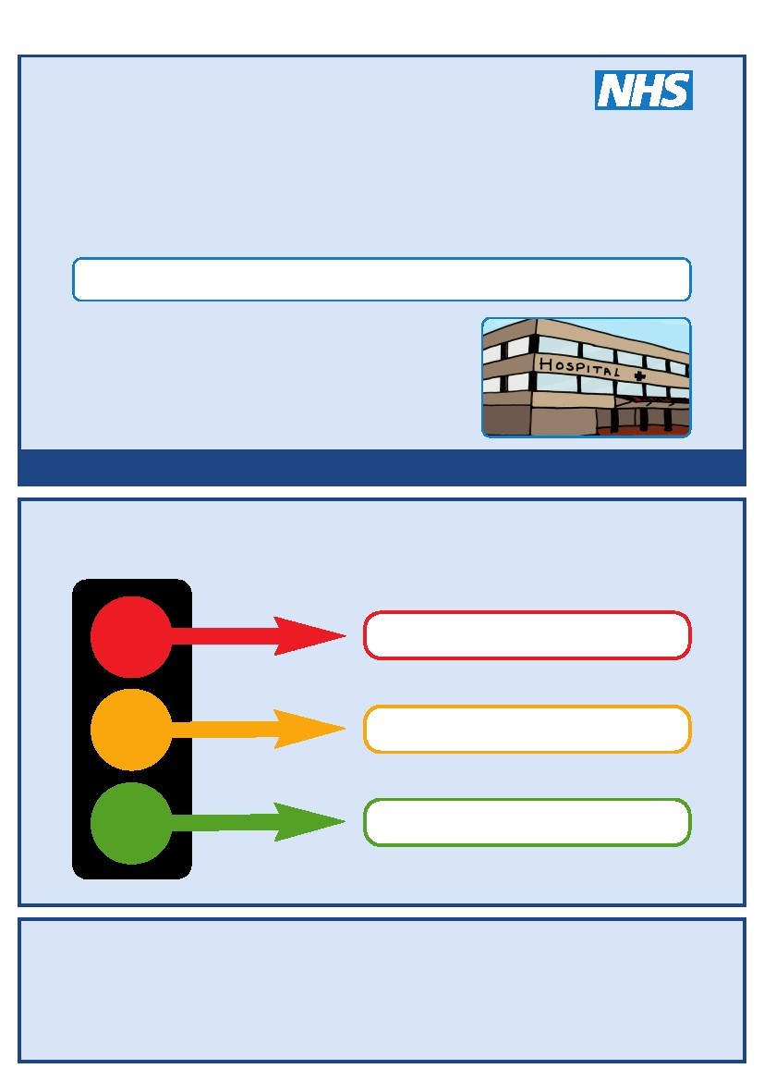
This is my
Hospital Passport
For people with learning disabilities coming into hospital
My name is:
If I have to go to hospital this book needs to
go with me, it gives hospital staff important
information about me.
It needs to hang on the end of my bed and a
copy should be put in my notes.
This passport belongs to me. Please return it when I am discharged.
Nursing and medical staff please look at my passport
before you do any interventions with me.
Things you must know about me
Things that are important to me
My likes and dislikes
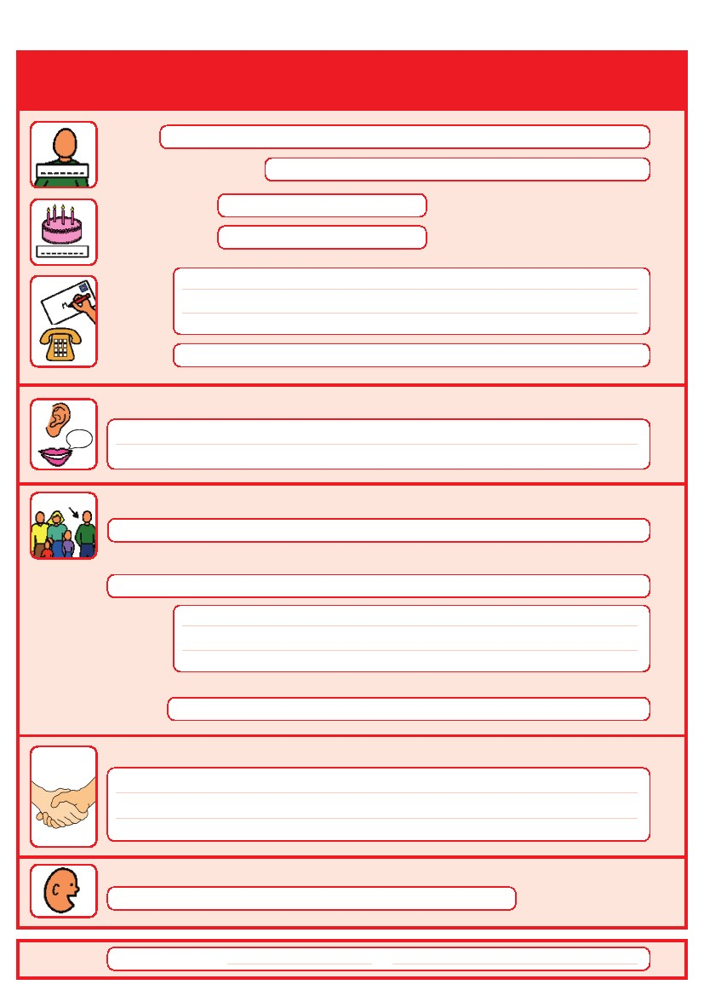
Things you must know about me
Name:
Likes to be known as:
NHS number:
Date of Birth:
Address:
Tel No:
How I communicate/What language I speak:
Family contact person, carer or other support:
Relationship e.g. Mum, Dad, Home Manager, Support Worker:
Address:
Tel No:
My support needs and who gives me the most support:
My carer speaks:
Date completed
by
1
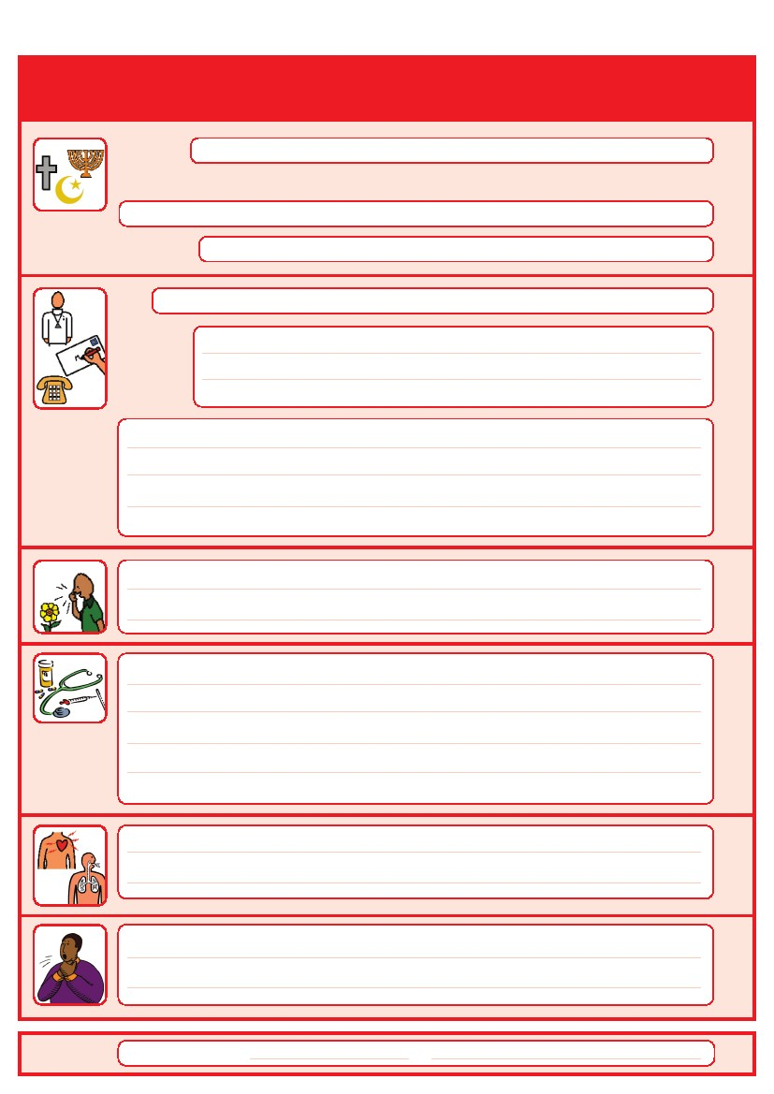
Things you must know about me
Religion:
Religious/Spiritual needs:
Ethnicity:
Address:
GP:
Tel No:
Other services/professionals involved with me:
Allergies:
Medical Interventions – how to take my blood, give injections, BP etc.
Heart
Breathing problems:
Date completed
Risk of choking, Dysphagia (eating, drinking and swallowing):
by
2
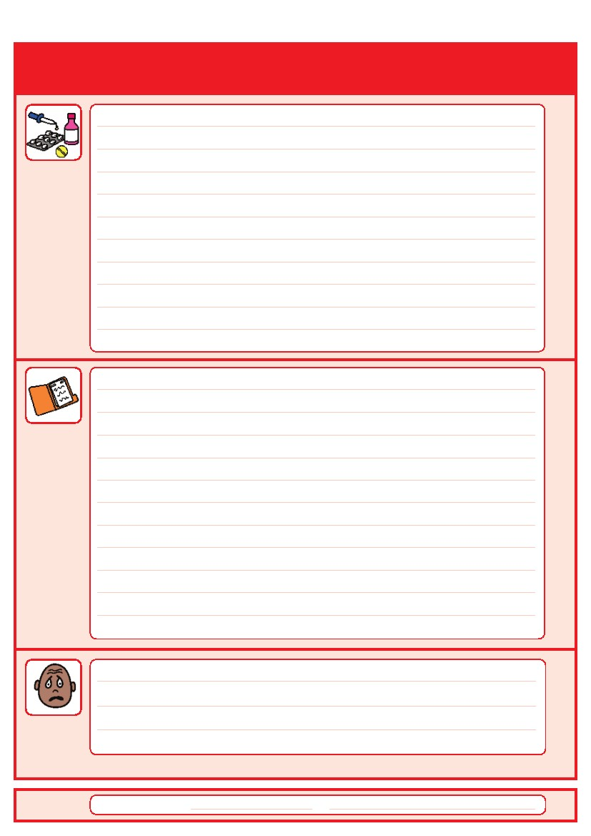
Things you must know about me
Current medication:

My medical history and treatment plan:
Date completed
What to do if I am anxious:
by
3
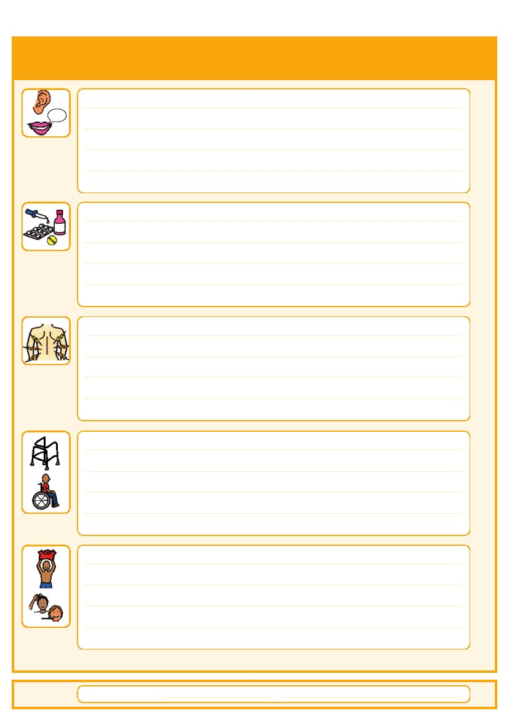
Things that are important to me
Date completed
How to communicate with me:
How I take medication: (whole tablets, crushed tablets, injections, syrup)
How you know I am in pain:
Moving around: (Posture in bed, walking aids)
Personal care: (Dressing, washing, etc)
by
4
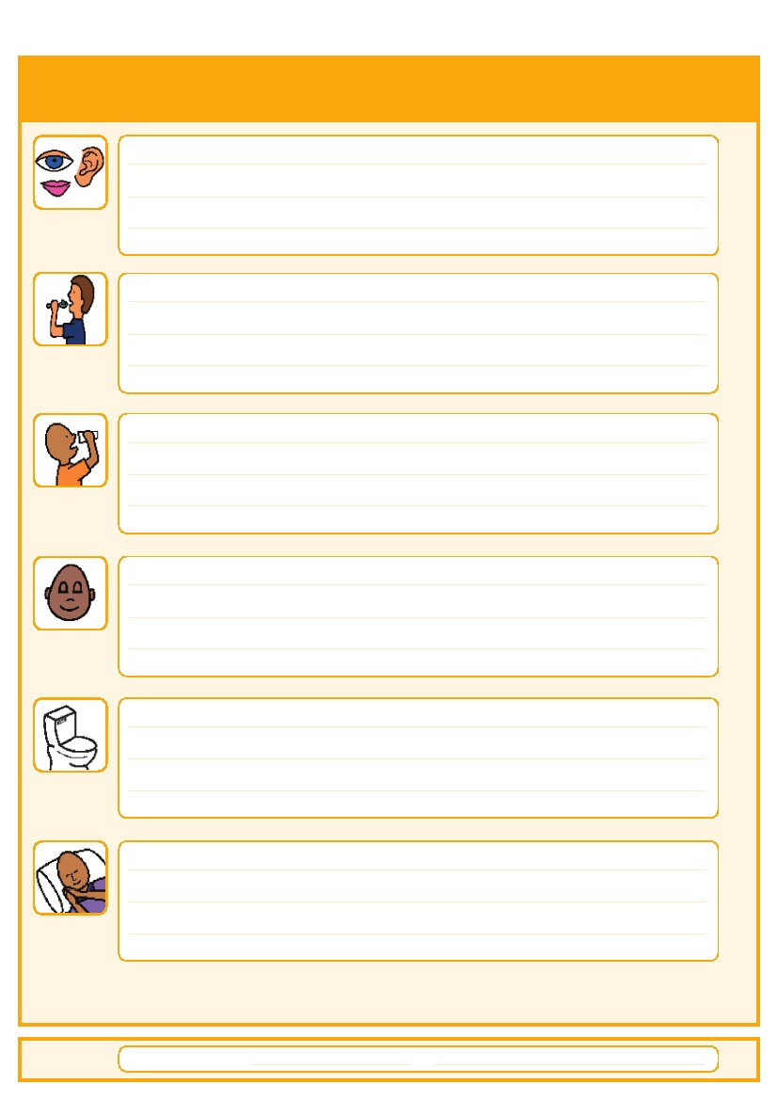
Things that are important to me
Date completed
Seeing/Hearing: (Problems with sight or hearing)
How I eat: (Food cut up, pureed, risk of choking, help with eating)
How I drink: (Drink small amounts, thickened fluids)
How I keep safe: (Bed rails, support with challenging behaviour)
How I use the toilet: (Continence aids, help to get to toilet)
Sleeping: (Sleep pattern/routine)
by
5
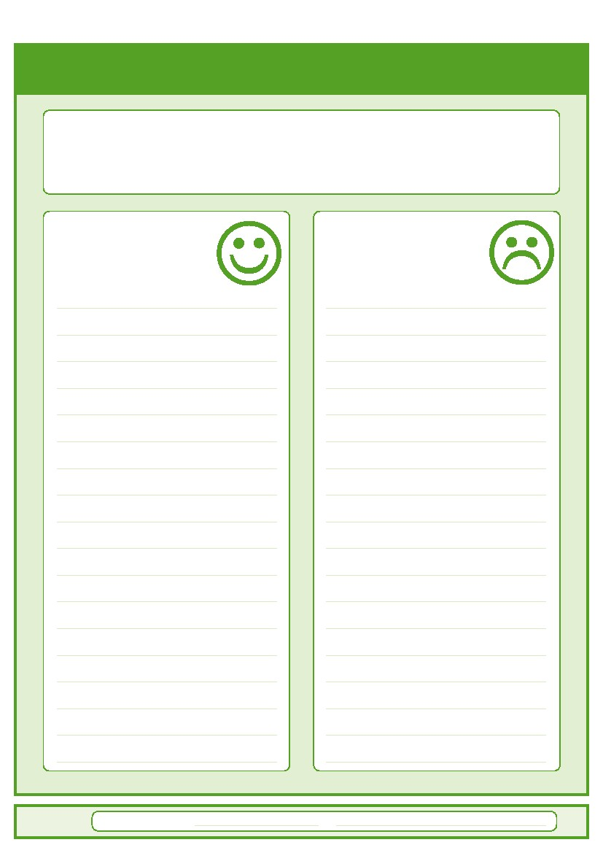
My likes and dislikes
Likes: for example - what makes me happy, things I like to do
i.e. watching TV, reading, music, routines.
Dislikes: for example - don’t shout, food I don’t like, physical touch.
Date completed
Things I like
Please do this:
Things I don’t like
Don’t do this:
by
6
7
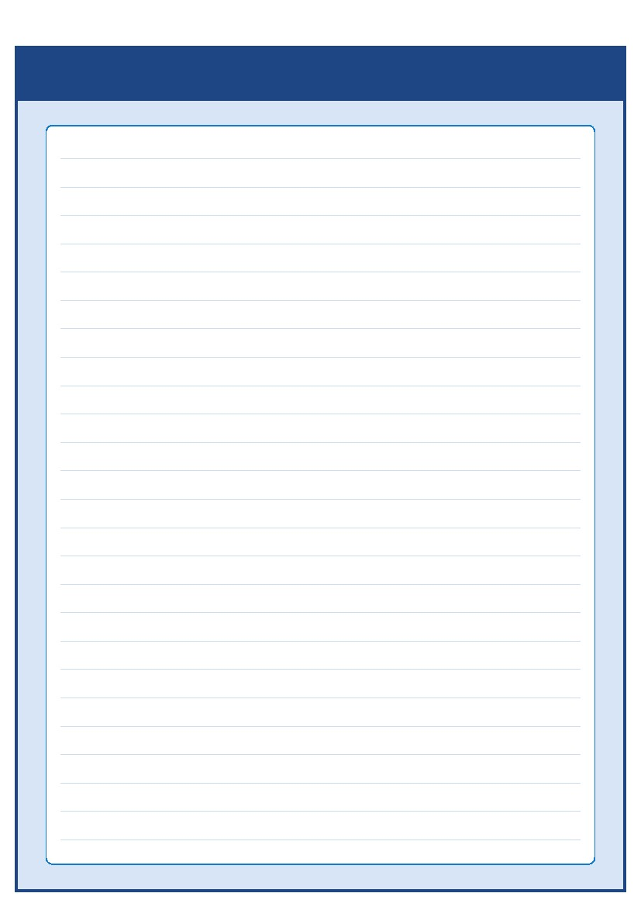 Notes

Contacts and useful websites
Community Learning Disability Teams (CLDT)
Halton Community Learning Disabilities Team – MerseyCare
Cheshire West – Wirral and Cheshire Community Partnership
01244 397 222
Cheshire East Community Learning Disabilities Team – Wirral and Cheshire Community Partnership
01625 509 013

0151 351 8899
Knowsley Community Learning Disabilities Team - MerseyCare
0151 426 5885
Liverpool Community Learning Disabilities Team - MerseyCare
0151 737 2219
www.easyhealth.org.uk
Sefton Community Learning Disabilities Team – MerseyCare
01704 383030

St Helens Community Learning Disabilities Team – MerseyCare
0151 426 5885
Wirral Community Learning Disabilities Service – Wirral and Cheshire Community Partnership
0300 303 3157
www.intellectualdisability.info
www.mencap.org.uk/gettingitright
8
This Hospital Passport was developed by the South West London Access to Acute Group and based
Please contact your local community learning disability team
if you have any questions about the passport
on original work by Gloucester Partnership NHS Trust.
Thank you to The Baked Bean Theatre Company, members of our community, Wandsworth
Community Learning Disability Team, members of the St Georges Access to Acute working party,
Merton CTPLD Community Nurses and the Corporate Design department at Wandsworth Council who
all inputted into the redesign of this document.
AS.42a (12.09)
